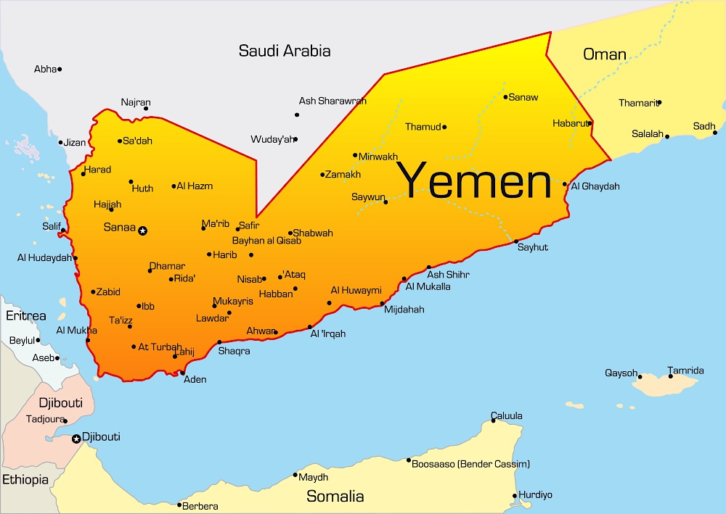
Partial Timeline:
- 17 July 1978 - Ali Abdulla Saleh elected by Parliament to be the President of the Yemen Arab Republic, while simultaneously holding the positions of chief of staff and commander-in-chief of the armed forces. Saleh ruled for 33 years.

- 2011 - Arab spring uprisings protested Saleh’s dictatorship

- 2012 – Saleh ousted by Abd-Rabbu Mansour Hadi

- January 2015 – Following a period of negotiations, Houthi tribal rebels and Saleh consolidated power and marched toward the capital city, Sana’a.

- 6 February 2015 - Houthis took over Sana’a; Hadi resigned, fled to the south of Yemen and then to Saudi Arabia

- Hadi forms a Saudi-led coalition of ten countries and reclaims his role as president. Bahrain, Kuwait, Qatar, the UAE, Egypt, Jordan, Morocco, Sudan, and Saudi Arabia round out the coalition.
Airstrikes were waged against IDP camps, civilian gatherings, including weddings, vehicles, including buses, residential areas, medical facilities, schools, mosques, markets, factories, warehouses, roads, cranes and four Doctors Without Borders hospitals.
U.S. military support for Saudi-led coalition (Source: Human Rights Watch report, 03/2016)
- July 2015, the US Defense Department approved a number of weapons sales to Saudi Arabia, including a US $5.4 billion deal for 600 Patriot Missiles and a $500 million deal for more than a million rounds of ammunition, hand grenades, and other items, for the Saudi army.

- According to the US Congressional review, between May and September, the US sold $7.8 billion worth of weapons to the Saudis.
- In October, the US government approved the sale to Saudi Arabia of up to four Lockheed Littoral Combat Ships for $11.25 billion.
In November, the US signed an arms deal with Saudi Arabia worth $1.29 billion for more than 10,000 advanced SAMs. including laser-guided bombs, “bunker buster” bombs, and MK84 general purpose bombs; the Saudis have used all three in Yemen.

A Brief Political History
- 26 March 2015 – At Hadi’s request, Saudi-led coalition begins military operations and airstrikes.

Airstrikes were waged against IDP camps, civilian gatherings (including weddings), vehicles (including buses), residential areas, medical facilities, schools, mosques, markets, factories, warehouses, roads, cranes and four hospitals run by Doctors Without Borders.
U.S. military support for Saudi-led coalition
(Source: Human Rights Watch report, 03/2016)
July 2015 - the US Defense Department approved a number of weapons sales to Saudi Arabia, including a US $5.4 billion deal for 600 Patriot Missiles and a $500 million deal for more than a million rounds of ammunition, hand grenades, and other items, for the Saudi army.

According to the US Congressional review, between May and September, the US sold $7.8 billion worth of weapons to the Saudis.
In October, the US government approved the sale to Saudi Arabia of up to four Lockheed Littoral Combat Ships for $11.25 billion.
In November, the US signed an arms deal with Saudi Arabia worth $1.29 billion for more than 10,000 advanced SAMs. These included laser-guided bombs, “bunker buster” bombs, and MK84 general-purpose bombs. The Saudis have used all three in Yemen.

