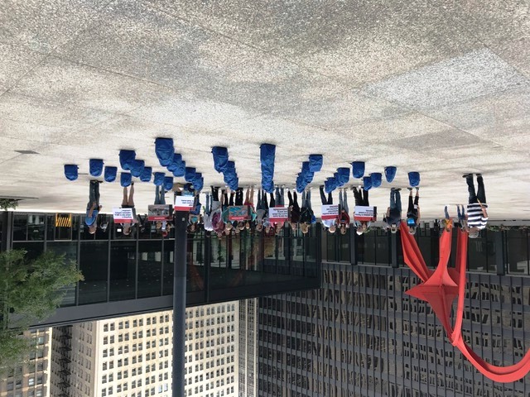

34 Backpacks: an ongoing commemoration of Yemeni children killed on August 9
Felton Davis, who coordinates a weekly vigil in NYC calling for an end to the U.S. war against Yemen, sent us a letter written by Yemen’s Minister of Education which names the students and teachers who were killed when a Saudi warplane fired a 500 lb. bomb, made in the U.S., at their school bus. We feel relieved to know that ten children whom we believed had died are actually alive. The number of children killed was 34, not 44. Four of their teachers were killed along with 12 passers-by. 78 people were wounded, including 55 students. Our hearts also go out to the first responders, EMT workers and hospital staff whose courageous efforts to save and heal people also involved trying to determine the number of dead.
We encourage people to continue commemorating those who died in the April 9, 2018 attack. In Chicago, Voices and other peace groups gathered in the Federal Building Plaza where we set up blue backpacks to commemorate each child who had been killed. (UNICEF had issued blue backpacks to the children before they went on their outing).
Please let us know if you would like to set up a similar vigil in your area. We can equip people with placards describing the attack and naming each victim; we can also supply photos, sample fliers, press releases and information about setting up backpacks. Contact Voices at 773-878-3815 or write info@vcnv.org.
Here are the names released by the Yemeni Ministry of Education of those killed and injured in the August 9 attack:
Mohammad Yahya Yahya Faya, killed
11 years old
Zakaria Abdel Wahab Ali Faya, killed
10 years old
Ali Mohammed Hassan Da'i, killed
10 years old
Yousef Hussein Hussein Tayeb, killed
15 years old
Ahmed Zaid Hussein Tayeb, killed
12 years old
Ali Zaid Hussein Tayeb, killed
9 years old
Osama Zeid Ali Al-Hamran, killed
13 years old
Ali Zaid Ali Al-Hamran, killed
15 years old
Ali Abdul Rahim Ali Hashem, killed
9 years old
Akab Mohamed Hassan al-Abbadi, killed
12 years old
Turki Mohamed Hassan Abadi, killed
10 years old
Yousef Abdul Aziz Al-Dahdawi, killed
13 years old
Younis Abdul Aziz Al-Dahdawi, killed
11 years old
Yousef Abdullah Saleh Al-Hatafi, killed
10 years old
Abdullah Hussein Faisal Hajj, killed
12 years old
Hamid Mohammed Ayda Hadi, killed
10 years old
Yousef Hassan Mohammed Al-Dhib, killed
9 years old
Abdul Malik Abdul Rahman Abdullah Al-Dhib, killed
12 years old
Amjad Abdul Rahman Abdullah Al-Deeb, killed
10 years old
Mohamed Abdulsalam Abdullah Al-Dehayani, killed
12 years old
Abd al-Ilah Abdullah Hussein al-Razahi, killed
11 years old
Mohamed Abdel-Ilah Mohamed El-Hakim, killed
9 years old
Mohammed Abdullah Yahya Velita, killed
12 years old
Hassan Abdul Karim Ahmad Al Hadi, killed
10 years old
Ahmed Abdel Hakim Ali Amer, killed
11 years old
Mohamed Abdel Salam Hassan Houria, killed
9 years old
Yahia Mahdi Ezz El Din Houria, killed
12 years old
Hussein Mohammed Ahsan al-Ajri, killed
15 years old
Abdullah Abdulsalam Abdullah Taraf, killed
12 years old
Mohammad Yahya Mohammed Al-Ezzi, killed
8 years old
Yahya Mohammed Hussein Al-Arjari, killed
12 years old
Yousef Saleh Abdullah Al-Aqili, killed
10 years old
Mohammed Saeed Ali Salman, killed
13 years old
Waleed Abdullah Ali Ali Al-Khulani, killed
13 years old
Mohammed Abdul Hafeez Abdullah Steen, killed
28 years
Yahia Hussein Yahya Al-Bishri, killed
42 years old
Ali Hussein Hassan Al-Ajri, killed
27 years old
Ali Salah Zaid Faya, killed
48 years old
Abdul-Malik Abdullah Al-Da'i, wounded
9 years old
Hassan Hussein Qasim Al-Shawi, wounded
10 years old
Hussein Yahya Yahya Al-Shawi, wounded
12 years old
Hussein Qasim Hussein Al-Shawi, wounded
11 years old
Ibrahim Mohammed Hamid Al-Shahari, wounded
10 years old
Taha Hassan Abdullah al-Shahari, wounded
9 years old
Saber Massoud Mesfer Jaber, wounded
12 years old
Hafez Abdullah Ali Al-Mahah, wounded
9 years old
Mohammed Khaled Qassem Al-Saadi, wounded
12 years old
Mohamed Ghaleb Ali Ghalebi, wounded
16 years old
Ahmed Mohamed Ali Swaid, wounded
16 years old
Hassan Mohamed Ali Hassan, wounded
12 years old
Faisal Mohammed Abdullah, wounded
12 years old
Mohammed Salem Salman, wounded
12 years old
Yahya Mohammed Ali Hanash, wounded
10 years old
Hassan Mohammed Ali Hanash, wounded
11 years old
Ahmed Abdel Rahman Mohsen Adlan, wounded
13 years old
Yahia Ali Mohammed Magali, wounded
10 years old
Hassan Abdul Rahman Ahmad Al-Ajri, wounded
11 years old
Hussein Ahmed Abdul Salam Al-Ajri, wounded
10 years old
Yahia Abdul Majeed Hussein Al-Ajri, wounded
10 years old
Younis Saleh Abdullah Al-Aqili, wounded
7 years old
Badr al-Din Hussein Yahya al-Katabari, wounded
10 years old
Izz al-Din Saleh Muhammad Abdullah, wounded
12 years old
Ahmed Abdel Rahman Mohsen Adlan, wounded
13 years old
Qassem Mohammed Abdullah Hashem Al Sharafi, wounded
7 years old
Mustafa Ghaleb Faisal Al-Wadai, wounded
12 years old
Mohamed Abdel-Rahim Ibrahim El-Shazly, wounded
13 years old
Mohamed Mutahar Ibrahim El Hadi, wounded
10 years old
Abdulrahman Mutahar Ibrahim El Hadi, wounded
12 years old
Hassan Ali Ahmad Al-Qasimi, wounded
13 years old
Abdel Rahman Tarash Ahmed Salam, wounded
12 years old
Ibrahim Tarash Ahmed Salam, wounded
14 years old
Ali Taha Ahmed Qassim Sharif, wounded
8 years old
Kamal Abdullah Mohammed Al-Sharafi, wounded
13 years old
Rafak Ali Salman Suleiman, wounded
13 years old
Abdul Hakim Ayza Yahya Al-Maas, wounded
12 years old
Taha Taleb Al-Sha'outi, wounded
16 years old
Yahia Hassan Daifallah Al Farah, wounded
10 years old
Sergeant Ali Noman, wounded
8 years old
Mokhtar Hadi Ahmed, wounded
6 years old
Hamad Jafar Thabet Al-Samaei, wounded
14 years old
Ibrahim Fares Ahmed, wounded
14 years old
Abdulrahman Faris Ahmed, wounded
17 years old
Abdel Rahman Hussein Ahmed, wounded
17 years old
Moaz Qassem Hassan, wounded
17 years old
Ahmed Mesfreli Malloh, wounded
17 years old
Younis Ali Ahmed Al-Katabari, wounded
13 years old
Mu'tasim Faisal Mohammed Abdullah, wounded
16 years old
Majed Hussein Abdul Rahman Al-Amir, wounded
18 years old
Ramzi Saleh Ismail Abdullah, wounded
17 years old
Abdel Rahman Ali Yousef Al-Hawouri, wounded
17 years old
Ahmed Mohamed Ali Hanash, wounded
14 years old
Hassan Mohammed Ali Hassan, wounded
12 years old
Hussein Ali Mohammed Qasim Ada, wounded
41 years old

